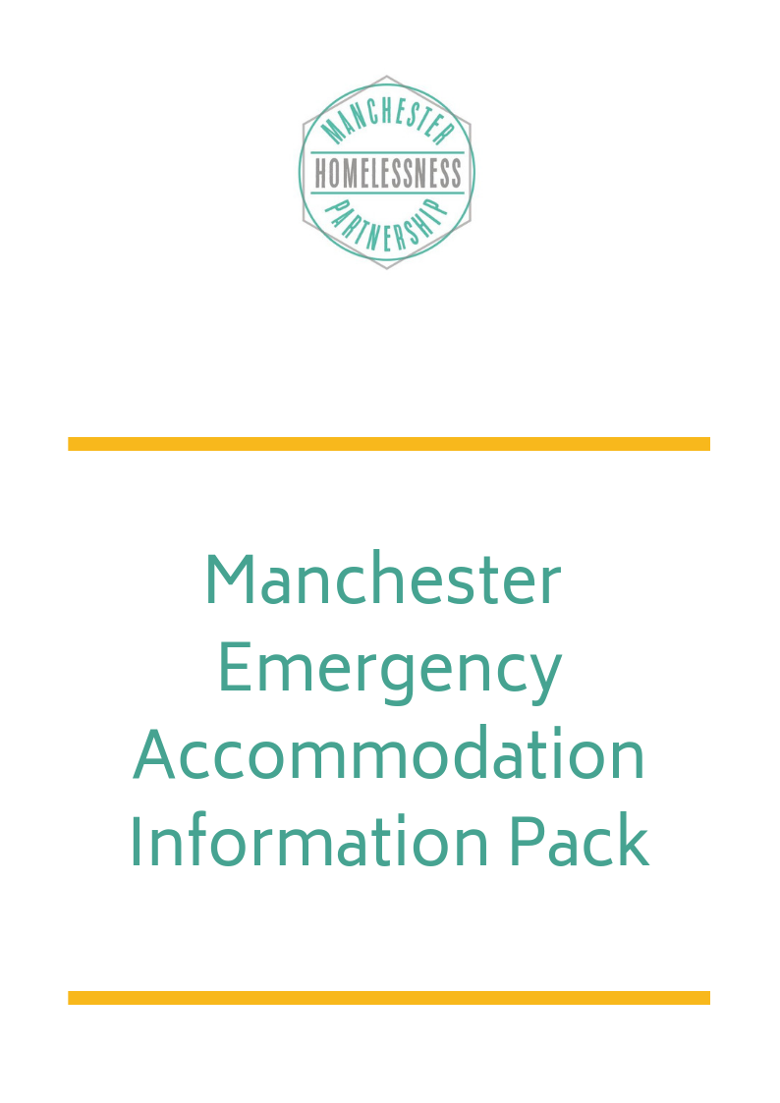

Emergency Accommodation Standards

Emergency Accommodation providers in Manchester all work in line with Manchester’s Minimum Standards for Emergency Accommodation. These standards have been drawn up with people who have experience of staying in emergency accommodation and people who provide and commission accommodation and support services. The aim is to ensure that all emergency accommodation which is provided in Manchester is of a suitable standard - provides people with a safe place to stay, where they are treated with dignity and respect and are helped to move on to supported or permanent accommodation with appropriate support.

For the purpose of this document Emergency Accommodation refers to accommodation that is provided to help ensure that people who are homeless do not have to sleep rough, including accommodation that is provided during periods of severe cold weather but excludes B+B/UTA and regular Support Accommodation/hostels which are covered by other regulations.

Types of Emergency Accommodation
There are a variety of types of Emergency Accommodation:

- Single Room Accommodation (or rooms for couples or friends who request a preference to share)
With other shared facilities in the building, with 24-hour access to the building and support provided by experienced staff

- “Night Shelters”
Shared accommodation, usually in one or two rooms and where people do not have 24-hour access to the accommodation.

- “Sit up accommodation” (which may provide people with beds)
Is usually provided by existing supported accommodation as an additional provision and may involve using communal areas, particularly during periods of severe cold weather.

- “pods” and “shared rooms”
There may be between 2-8 people sharing a room with other facilities provided in the building or in a neighbouring building.

Emergency Accommodation Action Group – Get Involved
This booklet and the emergency accommodation standards were drawn up by the Emergency Accommodation Action Group of the Manchester Homelessness Partnership. The group continues to meet on a regular basis to help support the provision of Emergency Accommodation and to continue to improve standards. The group is open to people who are living in or who have stayed in emergency accommodation and to workers from other services. Contact amanda@boothcentre.org.uk to get involved.

How to get into Emergency Accommodation – Referral Routes
For people wanting to get into Emergency Accommodation and for services which want to help people to access Emergency Accommodation, but don’t do this as part of their main service, the best route maybe via a support service.
These services can make referrals to all or some of the Emergency Accommodation outlined in this booklet.

Name of Service | Address | Phone number | Opening Times | Accept self-referrals and referrals from other services
Barnabus | Beacon, 45 Bloom Street, M1 3LY | 0161 237 3223 | Monday to Friday 10.30 – 1pm + 7.45 – 9pm | Yes
The Booth Centre | Edward Holt House, Pimblett Street, M3 1FU | 0161 835 2499  info@boothcentre.org.uk | Drop-in Monday to Friday 9-12  (office hours 8-4pm) | Yes
Centrepoint | CCP, 52 Oldham Street, M4 1LE  + Signpost, St Andrew's Hall, Wythenshawe M22 0DW | 0161 228 7654  Helpline open Monday to Friday 9-5pm | CCP is open Monday to Friday 10-12.30 and then 1.30-4.30.  Signpost (Wythenshawe) is open Monday to Friday 10-12 and then 1.00-4.00 | Yes
On The Out | Federation House, 2 Federation Street, M44BF Manchester Town Hall | 07853460206 07452809664 | Extension Drop in at Manchester Town Hall Extension Mondays 12 - 5pm Otherwise call to arrange to meet | Yes
Riverside Outreach | Brydon Court  1-3 Union Street  Ardwick, M12 4JD | 0161 273 1454 |  | Yes
The Rough Sleeper Team | Manchester Town Hall Extension | Duty Line  0161 234 5338  roughsleepersteam@manchester.gov.uk | Monday to Friday 6.00am - 9.30pm  Saturday & Sunday  8.00am - 3.30 pm | Yes
Manchester Emergency Accommodation Information Pack
Please note services are constantly developing and this information is current for August 2019

Name of Project | Boaz Trust Night Shelter
Name of Organisation | Boaz Trust
Address of Project (indicate if the location changes) | Different venue each night
Contact telephone number | 0161 202 1056
Contact email address | nightshelter@boaztrust.org.uk
Date the Project is due to open/close – for winter only provision | 1st October 2019 – 30th April 2020
Who the project is for (e.g. Men/women, low/medium/high support needs etc.) | Destitute asylum seekers & refugees – Men only
Does the project accept dogs | No
Number of bed spaces | 12
Type of bed spaces e.g. Single room, 2/3 person pods, 3/6 people share rooms, dormitory | Large room - Sleeping mat/mattress on church floor
Opening Hours e.g. 24 hours, 8pm to 7am etc. | 6pm – 8am
Referral route – how are referrals made and who can make referrals | Online referral form www.boaztrust.org.uk
Any other relevant information

Manchester Emergency Accommodation Information Pack
Please note services are constantly developing and this information is current for August 2019

Name of Project | Brydon Court
Name of Organisation | The Riverside Group
Address of Project (indicate if the location changes) | 1-3 Union Street  Ardwick  M12 4JD
Contact telephone number | 0161 273 1454
Contact email address | Marie.smith@riverside.org.uk
Date the Project is due to open/close – for winter only provision | Open all year round
Who the project is for (e.g. Men/women, low/medium/high support needs etc.) | Any gender and couples, people with animals, must have a history of rough sleeping for over 12 months and complex needs
Does the project accept dogs | Yes
Number of bed spaces | 6 emergency bed spaces
Type of bed spaces e.g. Single room, 2/3 person pods, 3/6 people share rooms, dormitory | 2 rooms 3 beds in each
Opening Hours e.g. 24 hours, 8pm to 7am etc. | 24 hours
Referral route – how are referrals made and who can make referrals | Riverside outreach or Rough Sleepers Team
Any other relevant information | The bed spaces are not suitable for people with low needs

Manchester Emergency Accommodation Information Pack
Please note services are constantly developing and this information is current for August 2019

Name of Project | Cornerstone Day Centre
Name of Organisation | Caritas Diocese of Salford
Address of Project (indicate if the location changes) | 104B Denmark Road  M15 6JS  Manchester
Contact telephone number | 0161 232 8888
Contact email address | a.mcintyre@cornerstonecds.org.uk
Date the Project is due to open/close – for winter only provision | Open all year round except during the weekends.
Who the project is for (e.g. Men/women, low/medium/high support needs etc.) | Temporary accommodation for men and women with low/medium support needs.
Does the project accept dogs | No
Number of bed spaces | 16 bed spaces (A Bed For Every Night)
Type of bed spaces e.g. Single room, 2/3 person pods, 3/6 people share rooms, dormitory | Temporary shared Pods (2/3 People)
Opening Hours e.g. 24 hours, 8pm to 7am etc. | Monday 10.30am to 4pm  Tuesday 10.30am to 2pm  Wednesday 10.30am to 4pm  Thursday 10.30am to 4pm  Friday 10.30am to 4pm  Saturday and Sunday Closed
Referral route – how are referrals made and who can make referrals | Everyone can make a referral to Cornerstone by visiting Cornerstone or by phone and email.
Any other relevant information | Cornerstone is a day centre providing services to vulnerable and disadvantaged adults. We help people facing a wide range of social issues. Cornerstone welcomes people from all backgrounds and operates a policy of non-discrimination. Our aim, in its broadest sense, is to provide a service that enhances the quality of life of our clients and bring together people from all backgrounds helping build a better community.  Day Centre Services  - Computer room  - Safe Haven Night Provision  - Education Service
Manchester Emergency Accommodation Information Pack
Please note services are constantly developing and this information is current for August 2019

Name of Project | Greater Together Manchester Night Shelter  Rolling | Greater Together Manchester Night Shelter  Static
Name of Organisation | Greater Together Manchester | Greater Together Manchester
Address of Project (indicate if the location changes) | Location changes | Location given once referral accepted
Contact telephone number | 07393 574 571 (referrals – subject to change) | 07393 574 571 (referrals – subject to change)
Contact email address | nightshelter@greatertogethermanchester.org (general)  support@greatertogethermanchester.org (referrals) | nightshelter@greatertogethermanchester.org (general)  support@greatertogethermanchester.org (referrals)
Date the Project is due to open/close – for winter only provision | October to May | October (end) to April
Who the project is for (e.g. Men/women, low/medium/high support needs etc.) | Men, 18+, low-medium support needs | Men, 18+, low-medium support needs
Does the project accept dogs | No. | Not at this time
Number of bed spaces | 12 | 15
Type of bed spaces e.g. Single room, 2/3 person pods, 3/6 people share rooms, dormitory | Single beds in a shared and open space | Single beds in a shared and open space
Opening Hours e.g. 24 hours, 8pm to 7am etc. | 18:30-8:30 | 17:30-12:00 (subject to change)
Referral route – how are referrals made and who can make referrals | Via Support Workers and Advice Team at the Booth Centre | Through centralised Gateway system
Any other relevant information

Manchester Emergency Accommodation Information Pack
Please note services are constantly developing and this information is current for August 2019

Name of Project | Newbury House & Dispersed
Name of Organisation | The Riverside Group
Address of Project (indicate if the location changes) | 80 Daisy Bank Road  Manchester  M14 5GJ
Contact telephone number | 0161 224 5729
Contact email address | Kerry.kelly@riverside.org.uk
Date the Project is due to open/close – for winter only provision | Open all year round
Who the project is for (e.g. Men/women, low/medium/high support needs etc.) | Any gender and couples, people with animals, must have a history of rough sleeping for over 12 months and complex needs
Does the project accept dogs | Yes
Number of bed spaces | 8 emergency bed spaces
Type of bed spaces e.g. Single room, 2/3 person pods, 3/6 people share rooms, dormitory | 1 room with 2 sharing  1 room with 6 sharing - male
Opening Hours e.g. 24 hours, 8pm to 7am etc. | 24 hours
Referral route – how are referrals made and who can make referrals | Riverside outreach or Rough Sleepers Team
Any other relevant information | The bed spaces are not suitable for people with low needs

Manchester Emergency Accommodation Information Pack
Please note services are constantly developing and this information is current for August 2019

Name of Project | Rochdale Road
Name of Organisation | The Riverside Group
Address of Project (indicate if the location changes) | 686 Rochdale road  M9 5TT
Contact telephone number | 07970402787
Contact email address | gary.george@riverside.org.uk
Date the Project is due to open/close – for winter only provision | Open all year round
Who the project is for (e.g. Men/women, low/medium/high support needs etc.) | Any gender and couples, people with animals, must have a history of rough sleeping for over 12 months and complex needs
Does the project accept dogs | Yes
Number of bed spaces | 24 bed spaces in 15 rooms
Type of bed spaces e.g. Single room, 2/3 person pods, 3/6 people share rooms, dormitory | 2 rooms for couples  Some single rooms and some shared rooms
Opening Hours e.g. 24 hours, 8pm to 7am etc. | 24 hours
Referral route – how are referrals made and who can make referrals | Riverside outreach or Rough Sleepers Team
Any other relevant information | The bed spaces are not suitable for people with low needs

Manchester Emergency Accommodation Information Pack
Please note services are constantly developing and this information is current for August 2019

Name of Project | SPIN
Name of Organisation | Supporting People In Need
Address of Project (indicate if the location changes) | Coverdale Baptist Church  Coverdale Crescent  Ardwick  Manchester  M12 4FG
Contact telephone number | 0161 272 9515
Contact email address | manchesterspin@gmail.com
Date the Project is due to open/close – for winter only provision | Provision open 24/7 until 31st July 2020
Who the project is for (e.g. Men/women, low/medium/high support needs etc.) | Provision is for Males - 23 years and over - Low Support Needs
Does the project accept dogs | Yes
Number of bed spaces | 14 ABEN beds  20 Spin Hostel Beds  34 Total
Type of bed spaces e.g. Single room, 2/3 person pods, 3/6 people share rooms, dormitory | Dormitory
Opening Hours e.g. 24 hours, 8pm to 7am etc. | Supporting People In Need is staffed 24/7
Referral route – how are referrals made and who can make referrals | Referrals to manchesterspin@gmail.com via Manchester City Council’s Rough Sleeper Team, The Booth Centre, Barnabus, Centrepoint & On The Out  We also provide a ‘sit up’ service to The Rough Sleeper team. Clients arriving via this route will be directed to one of the above services the following morning for a referral into the most suitable service that meets the client’s needs.  We send out a daily email to providers when there is a bed availability.
Any other relevant information | At SPIN we partner with training providers to provide work training courses, we also have wellbeing sessions, along with the garden project which we actively encourage all residents to get involved with.

Manchester Emergency Accommodation Information Pack
Please note services are constantly developing and this information is current for August 2019

Name of Project | Severe Cold Weather Provision
Name of Organisation | Commissioned by Manchester City Council (providers may include the Red Cross and other supported housing providers)
Address of Project (indicate if the location changes) | A range of services will be used including:  Sit up provision in existing supported housing  Temporary Night Shelter Provision (buildings are being sought)  There will also be some use of B+B provision
Contact telephone number | For information contact the Rough Sleeper Team 0161 234 5339
Contact email address | Roughsleepersteam@manchester.gov.uk
Date the Project is due to open/close – for winter only provision | This provision will be available each time the temperature drops to zero or below. The announcement that Severe Cold Weather Provision has been activated will be confirmed when processes have been agreed for 19/20
Who the project is for (e.g. Men/women, low/medium/high support needs etc.) | Anyone who is rough sleeping.
Does the project accept dogs | Yes
Number of bed spaces
Type of bed spaces e.g. Single room, 2/3 person pods, 3/6 people share rooms, dormitory | A mixture of night shelter accommodation, sit up accommodation and B+Bs.
Opening Hours e.g. 24 hours, 8pm to 7am etc. | Times to be confirmed and will be different for different projects.
Referral route – how are referrals made and who can make referrals | Referral information will be announced once it has been finalised but will probably be through the MAS Gateway. Organisations making referrals will include the Rough Sleeper Team, the Booth Centre, Barnabas, etc.
Any other relevant information

Manchester Emergency Accommodation Information Pack
Please note services are constantly developing and this information is current for August 2019

Name of Project | Stanley Grove
Name of Organisation | Sanctuary Supported Living
Address of Project (indicate if the location changes) | 62-64 Stanley Grove  Longsight  Manchester  M12 5GF
Contact telephone number | 0161 256 4007
Contact email address | stanley.grove@sanctuary-housing.co.uk
Date the Project is due to open/close – for winter only provision | Opened on the 25th March 2019, operates 12 months of the year
Who the project is for (e.g. Men/women, low/medium/high support needs etc.) | Men and Women high support needs
Does the project accept dogs | Yes
Number of bed spaces | 20
Type of bed spaces e.g. Single room, 2/3 person pods, 3/6 people share rooms, dormitory | A mixture of single rooms, double rooms, 1 triple room and a separate flat accommodating 3 females (2 in a shared room)
Opening Hours e.g. 24 hours, 8pm to 7am etc. | Stanley Grove is staffed 24/7
Referral route – how are referrals made and who can make referrals | Referrals via Manchester City Council’s Rough Sleeper Team.
Any other relevant information | The service has an activity timetable which includes, Arts and Craft, Paint for Change (up cycling furniture with a local artist) Breakfast Club, Food Around the World, Rhythm to Recovery (rhythmic musical activities to support social and emotional development) Knitting and a Natter

Manchester Emergency Accommodation Information Pack
Please note services are constantly developing and this information is current for August 2019

Name of Project | Victoria House Sit up
Name of Organisation | Sanctuary Supported Living
Address of Project (indicate if the location changes) | 50 Victoria street, Openshaw, m11 2ly
Contact telephone number | 0161 231 9400
Contact email address | Victoria.house@sanctuary-housing.co.uk
Date the Project is due to open/close – for winter only provision | 24/7 364 days a year
Who the project is for (e.g. Men/women, low/medium/high support needs etc.) | 6 spaces for men, 2 for woman. Shared rooms, all support needs, assessed before.
Does the project accept dogs | No
Number of bed spaces | 8
Type of bed spaces e.g. Single room, 2/3 person pods, 3/6 people share rooms, dormitory | Shared room. 6 men to male, 2 to women.
Opening Hours e.g. 24 hours, 8pm to 7am etc. | Staffed 24/7
Referral route – how are referrals made and who can make referrals | Referrals to rsi.victoriahouse@sanctuary-housing.co.uk.  Referrals should be made via the City Council’s Rough Sleeper Team, Barnabus, The Booth Centre, On The Out or Centrepoint.  We send out email to providers when there is a bed available and the reply to above email on the Victoria House referral form. The client is then accepted/rejected after assessment.
Any other relevant information

